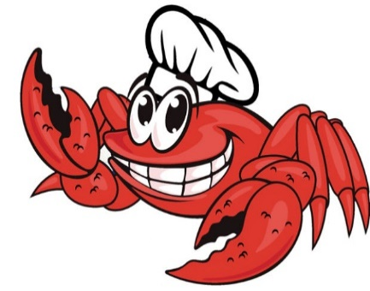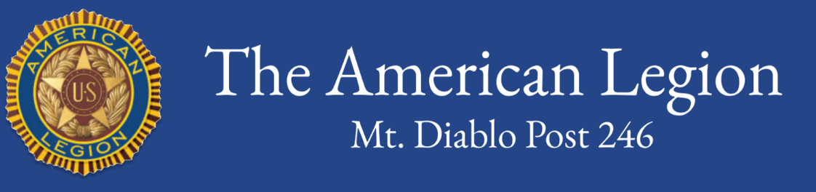

*Cherie Garcia-Day*

WHITE

*Sponsoring our event is another great way to support our programs while gaining additional visibility for your business, club, or group in the community. We are making four levels of sponsorships available: Gold, Red, White, and Blue.*

*Please call 925-272-8480 or email* [*commanderpost246@gmail.com*](mailto:commanderpost246@gmail.com) *for more information.*

***New sponsors:* GOLD**

**BLUE**

**AMERICAN LEGION**

**CRAB FEED DINNER & FUNDRAISER**

**Mt. Diablo Post 246 is again planning for our annual crab feed. Among other things, funds raised pay delegate fees for 14 local high school juniors to participate in American Legion Boys & Girls State and American Legion Auxiliary Girls State programs this summer.**

January 27, 2024

CRAB FEED

LIVE AUCTION

RAFFLE

ONLINE AUCTION

VETERANS MEMORIAL BUILDING

105 EAST PROSPECT AVE., DANVILLE

#### The American Legion enhances the well-being of America's veterans, their families, our military, and our communities by our devotion to mutual helpfulness.